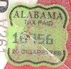  Alabama | 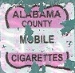  Alabama, Mobile County | 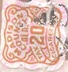  Alabama, Madison County | 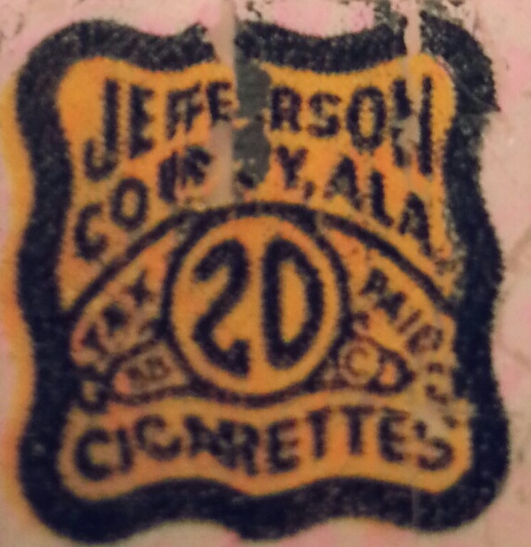  Alabama, Jefferson County |  | 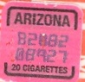  Arizona | 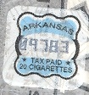  Arkansas
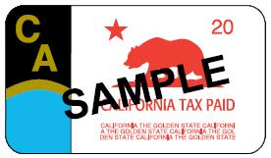  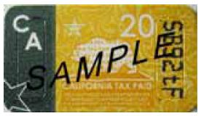  California | 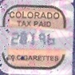  Colorado | 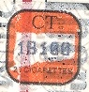  Connecticut | 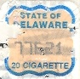  Delaware |  | 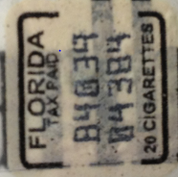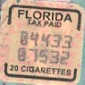  Florida
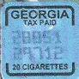  Georgia | 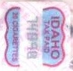  Idaho | 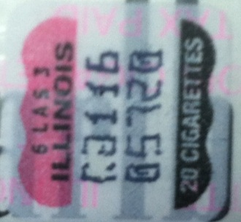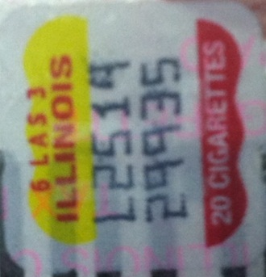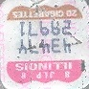  Illinois |  |  |  | 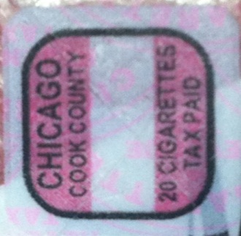  Illinois: Chicago, Cook County
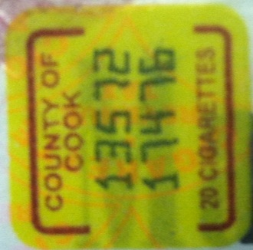  Illinois: Cook County | 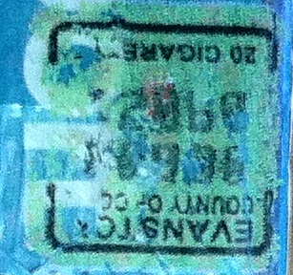  Illinois: Evanston, Cook County | 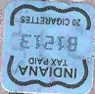  Indiana | 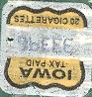  Iowa |  | 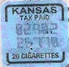  Kansas | 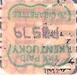  Kentucky
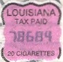  Louisiana | 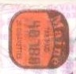  Maine | 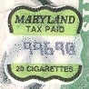  Maryland | 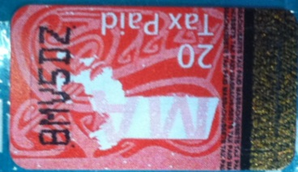  Massachusetts |  | 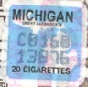  Michigan | 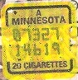  Minnesota
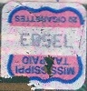  Mississippi | 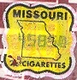  Missouri | 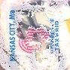  Missouri, Kansas City | 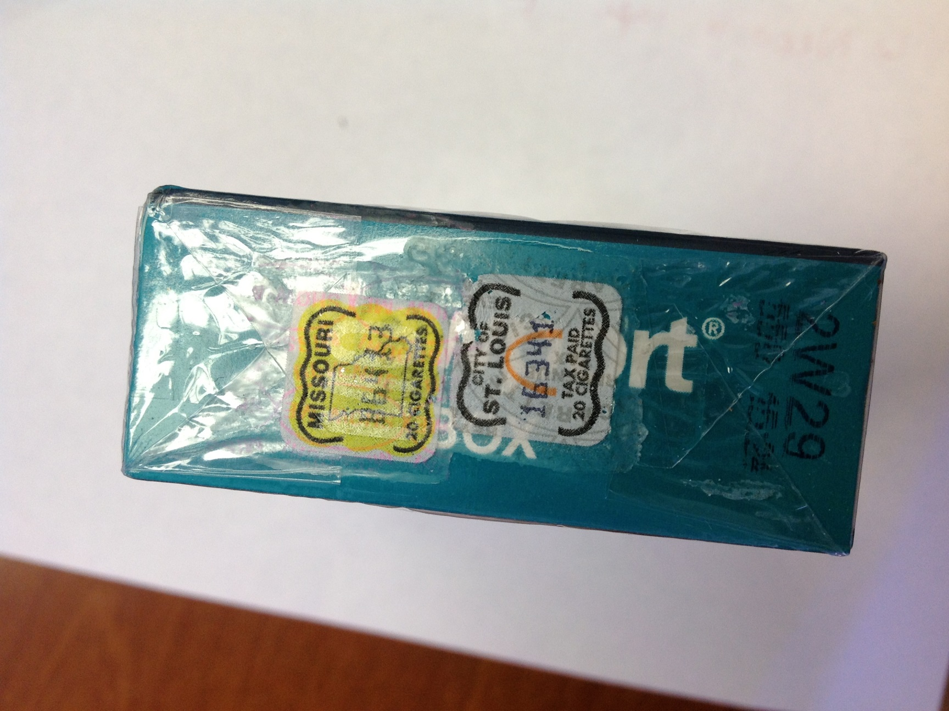  Missouri, City of St. Louis |  | 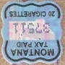  Montana | 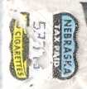  Nebraska
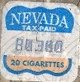  Nevada | 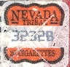  Nevada Tribal | 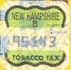  New Hampshire | 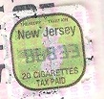  New Jersey |  | 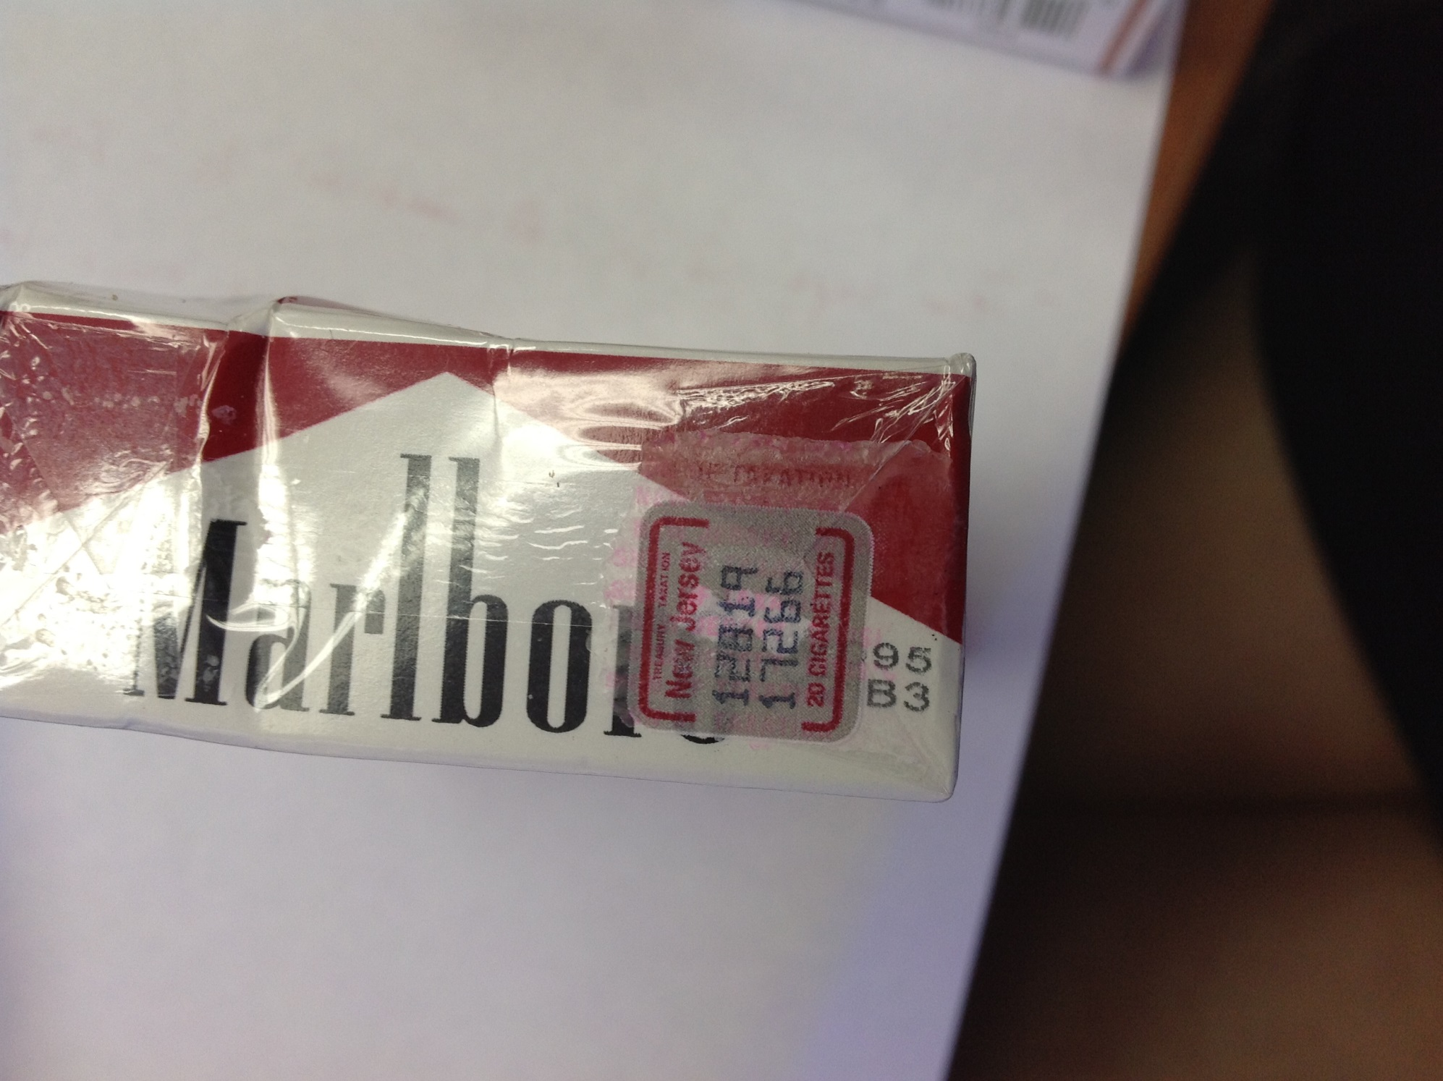  New Jersey | 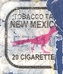  New Mexico
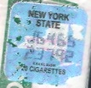  New York (STATE) | 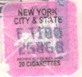  New York City- New York State (JOINT) | 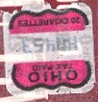  Ohio | 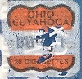  Ohio, Cuyahoga County | 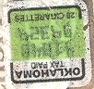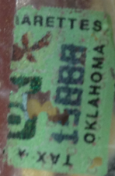  Oklahoma
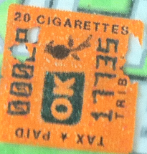  Oklahoma Tribal | 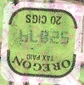  Oregon | 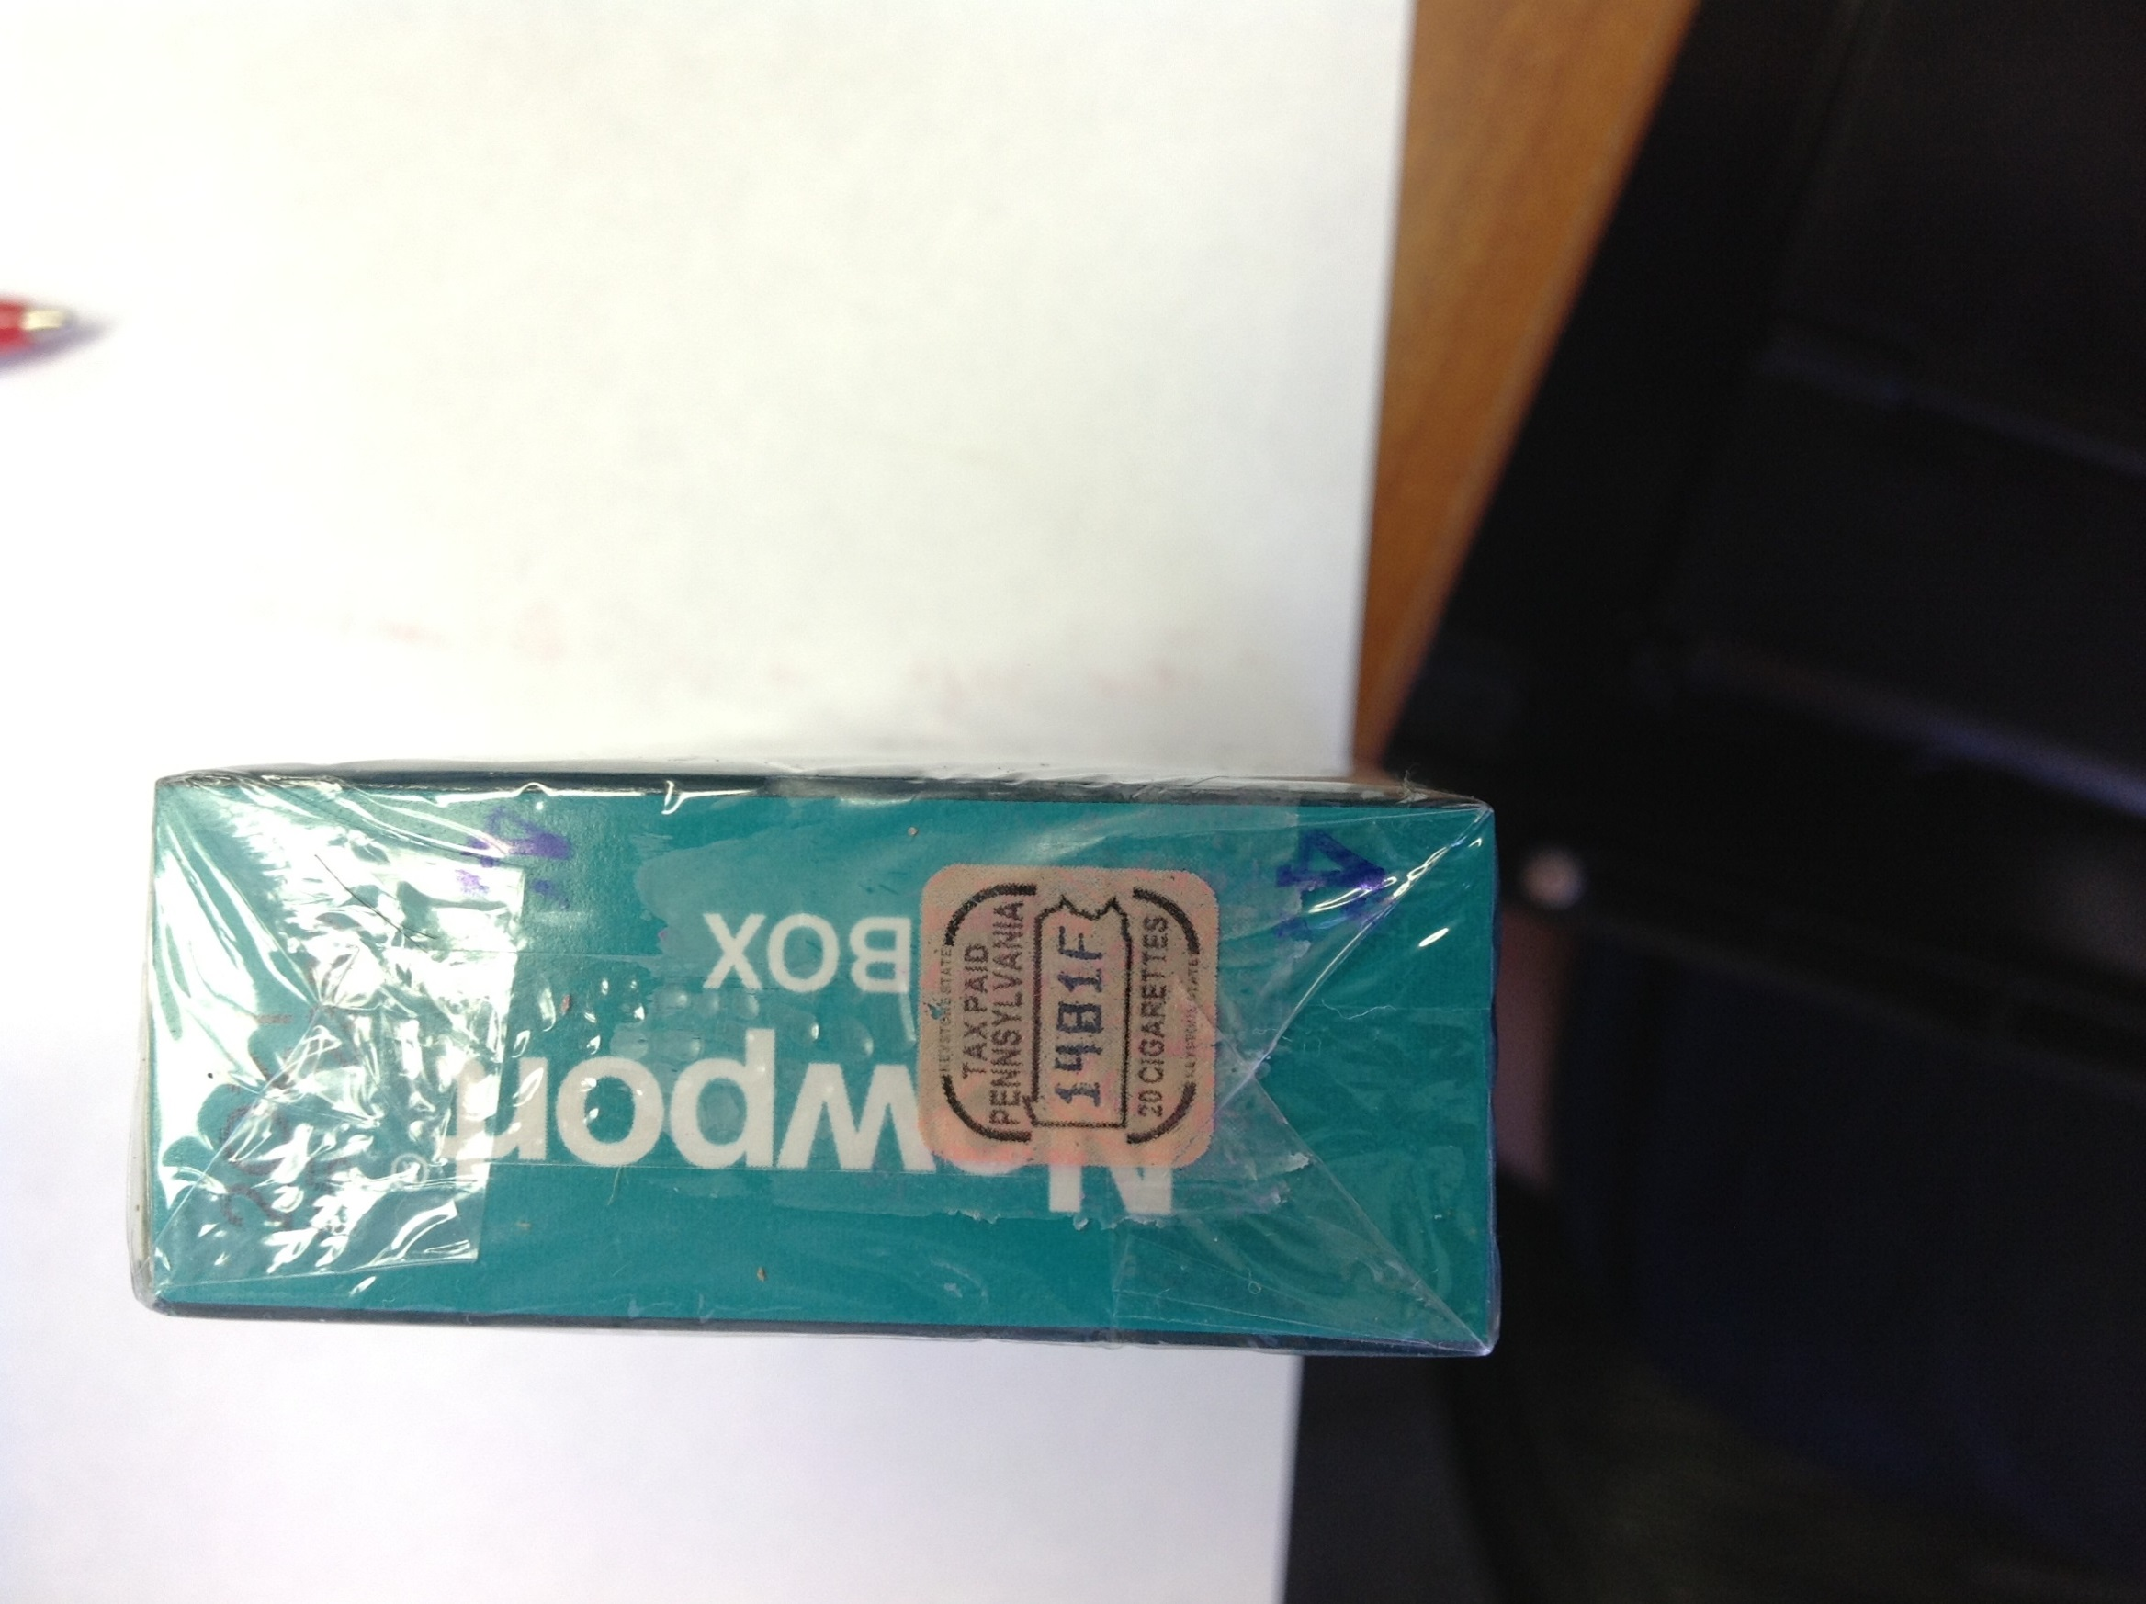  Pennsylvania | 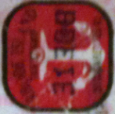  Rhode Island |  | 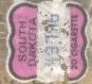  South Dakota | 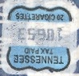  Tennessee
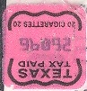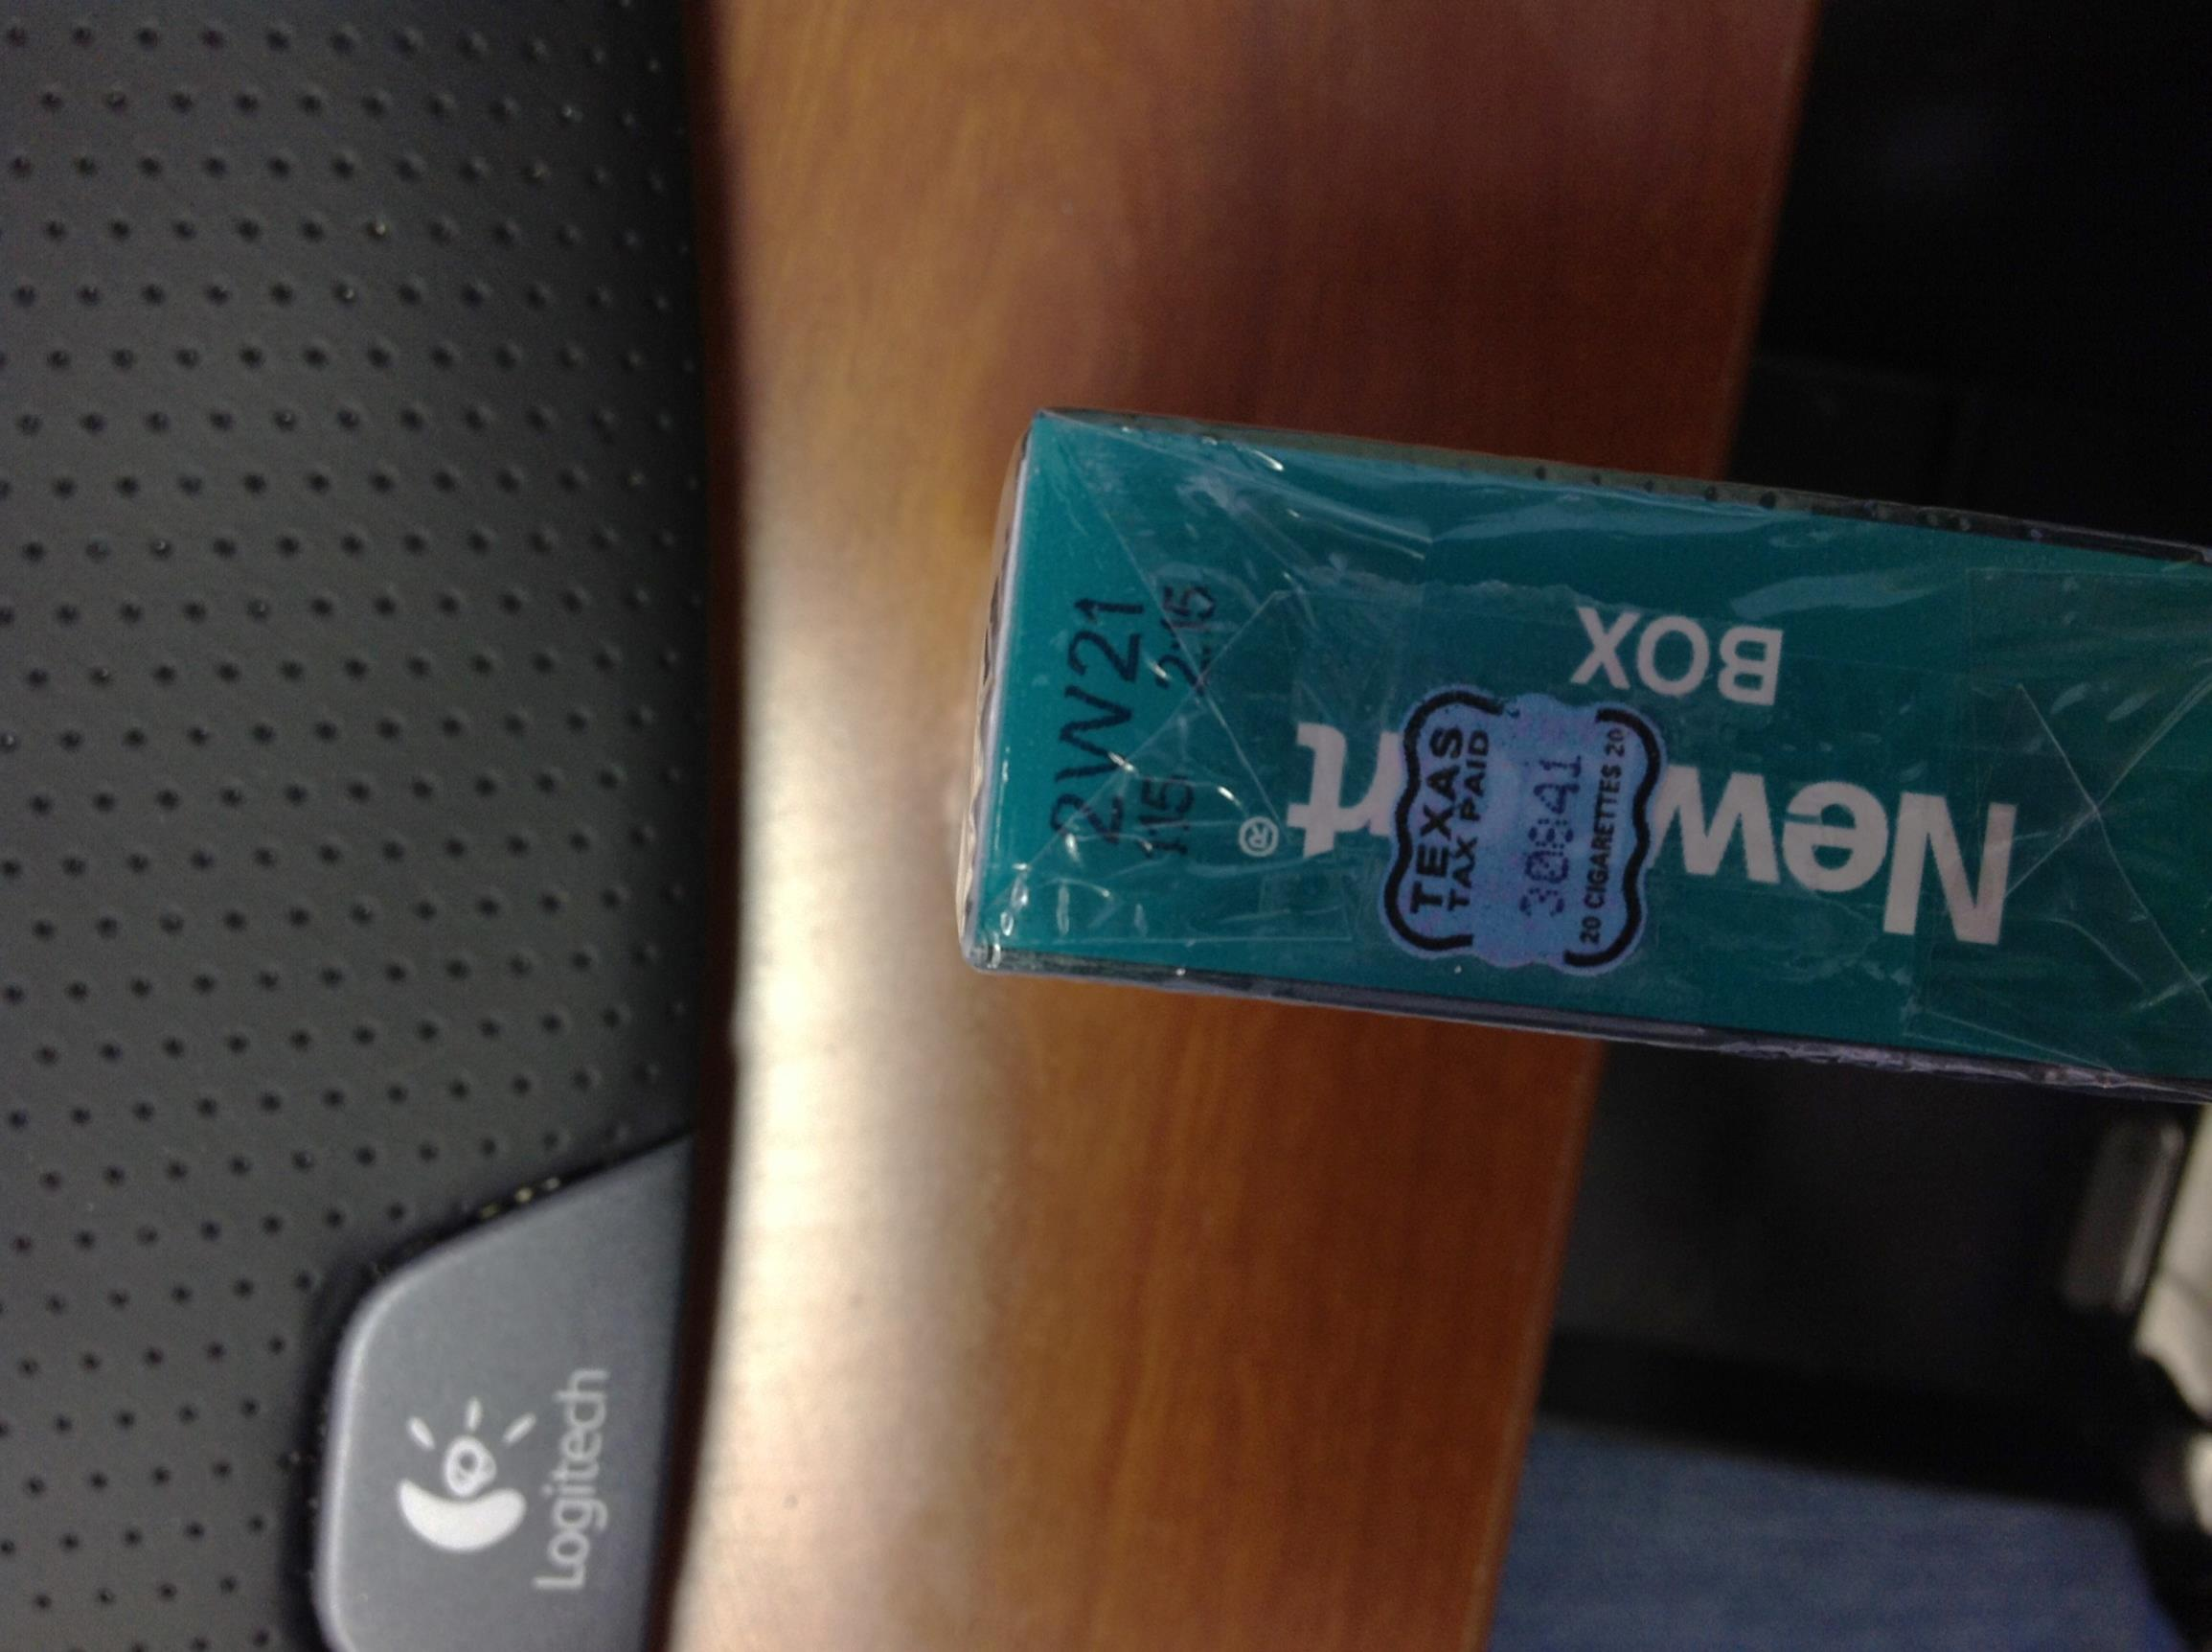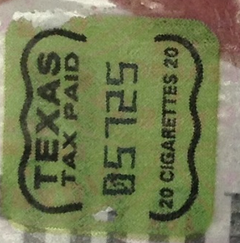  Texas |  |  |   Utah |  | 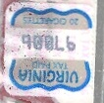  Virginia | 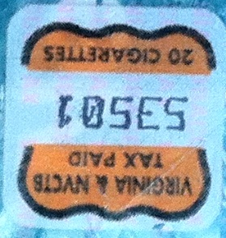  Virginia- NVCTB (JOINT)
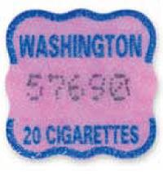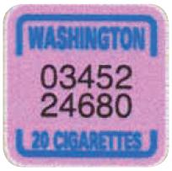  Washington |  | 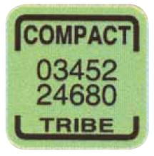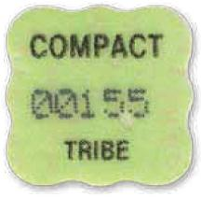  Washington Tribal |  |  | 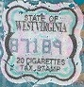  West Virginia | 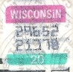  Wisconsin
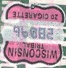  Wisconsin Tribal | 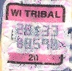  Wisconsin Tribal | 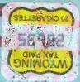  Wyoming | District of Columbia

Found during coding:
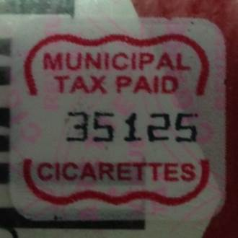  Municipal Stamp (general) | 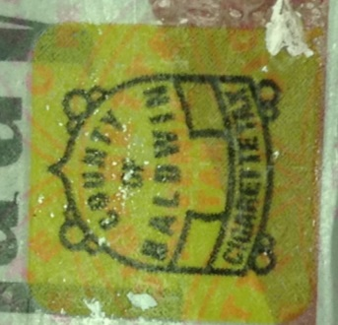  County of Baldwin (Alabama) | 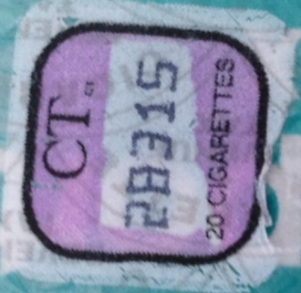  Connecticut | 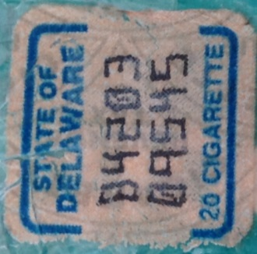  Delaware | 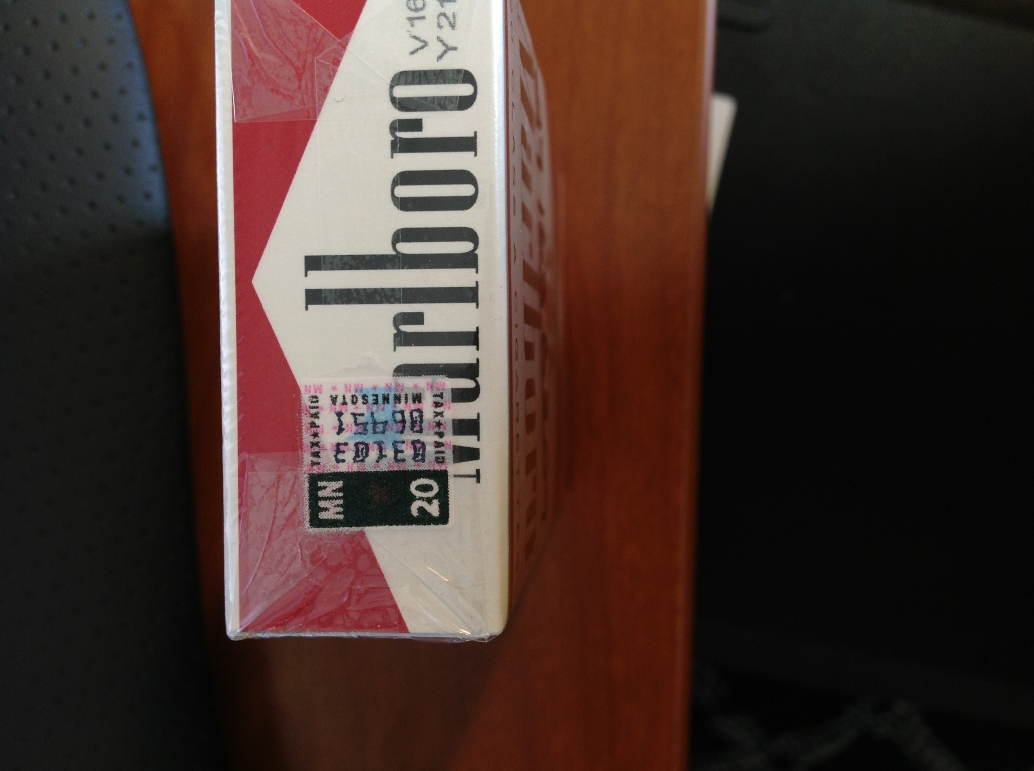  Minnesota | 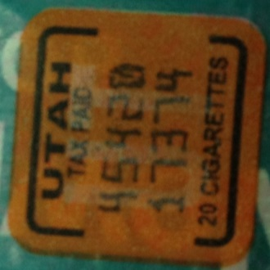  Utah

